I warmly welcome.

Further to our conversation I’m sending instructions on how to reinstall Tachospeed.

Below link to download your version of Tachospeed:

…….

- Database copy.

- Click on Tachospeed icon right mouse button and choose option: “Run as administrator”.
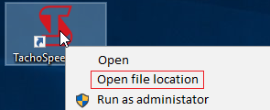
- Find and open „Baza” folder.

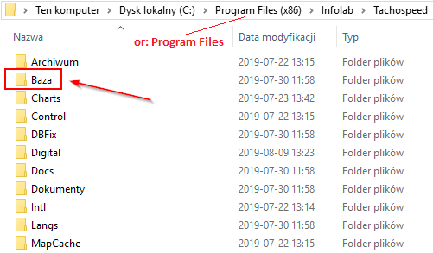

- Copy file: TACHOSPEED.gdb from there on portable device or deskop.

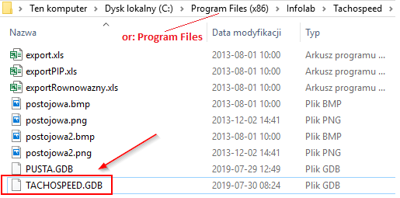

Good job! Your database copy has been done.

- TachoSpeed reinstall process.

Reinstall TachoSpeed – one stand version.
- Turn off TachoSpeed.
- Make copy (on portable device or deskop) your database (default database location C:/Program Files/Infolab/Tachospeed/Baza/TACHOSPEED.GDB). In MAX version of TachoSpeed may be more than one database! Copy all .gdb files from there pusta.gdb except.
  - Or according to “I. Database copy.”
- Uninstall TachoSpeed. (Control Panel -> Programs and functions)

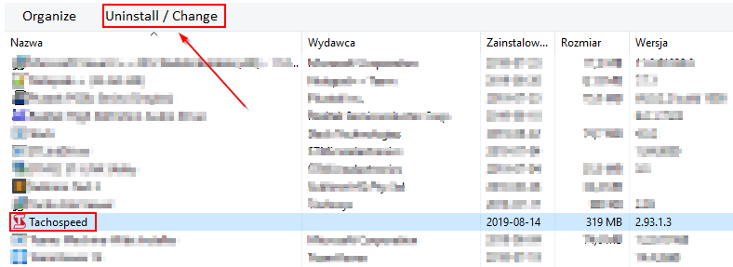
- Delete folder Infolab. Default location C:/Pliki Programów (x86)/Infolab

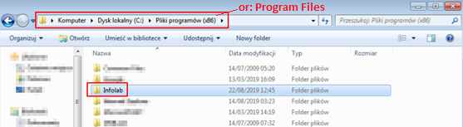

- Restart your PC. (optional)
- Turn off your antivirus program.
- Download TachoSpeed (link on start of email).
- Launch installer as administrator (screen below)

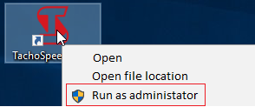

- After installation program ask restart your PC. Don’t have to restart.
- Replace database. Paste your copy from portable device or deskop. Default location C:/Program Files/Infolab/Tachospeed/Baza/
- Lauch TachoSpeed as administrator (only first launch do as administrator).

- Enter licence number.

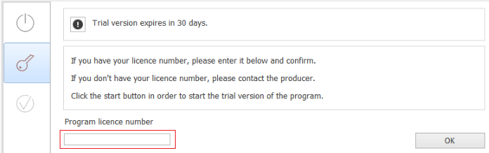

- After entered license number you are able to enter keys (licences) to additional modules.

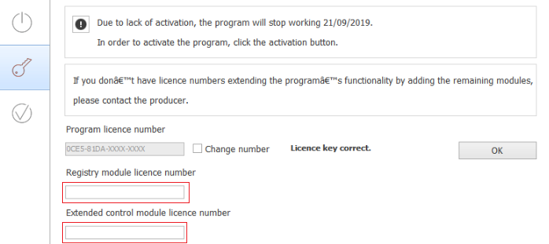

- Activate program. Enter TIN number and Company name and press “Automatic activation”.

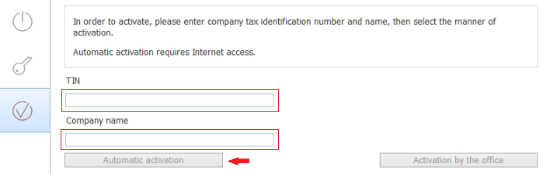

- If you can’t use automatic activation try “Activation by the office”. Send your validation code and TIF to office@tachospeed.com or pomoc@tachospeed.pl . We resend to you activation code.

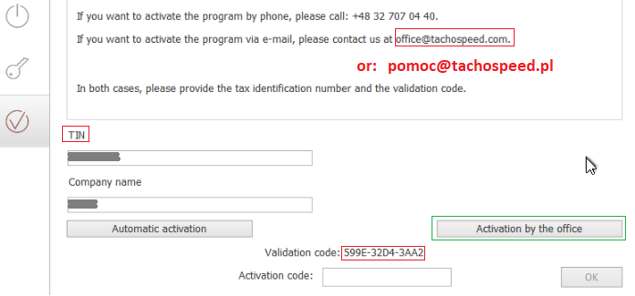

- Correct automatic activation or activation by the office (when you enter activate code) let you information about it.

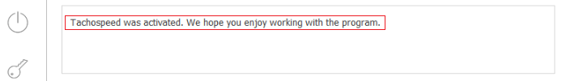

- In MAX version we may choose database to work (Administration -> Open database .gdb )
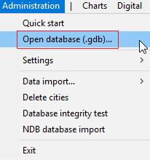

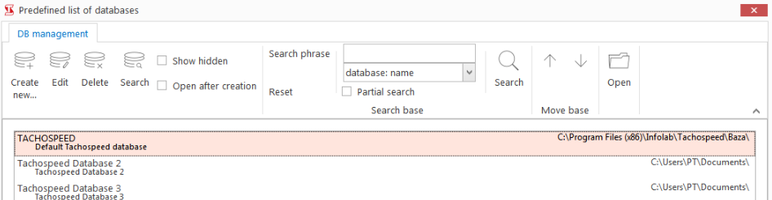

Transfer TachoSpeed to diffrent computer

- "previous" computer

- Turn off TachoSpeed.
- Make copy (on portable device or deskop) your database (default database location C:/Program Files/Infolab/Tachospeed/Baza/TACHOSPEED.GDB). In MAX version of TachoSpeed may be more than one database! Copy all .gdb files from there pusta.gdb except.
  - Or according to “I. Database copy.”

- "new" computer
- Turn off antivirus program.
- Download TachoSpeed (link on start of email).
- Launch installer as administrator (screen below)

- After installation program ask restart your PC. Don’t have to restart.
- Replace database. Paste your copy from portable device or deskop. Default location C:/Program Files/Infolab/Tachospeed/Baza/
- Launch TachoSpeed as administrator (only first launch do as administrator).

- Enter licence number and activate program (same like II. 12-16)
- In MAX version we may choose database to work (Administration -> Open database .gdb )

- When installation has been done you can uninstall TachoSpeed from previous computer.

In case of problems please contact me.

Greetings.

Best regards.

