I warmly welcome.

Further to our conversation I’m sending instructions on how to copy database of Tachospeed.

- Database copy.

- Click on Tachospeed icon right mouse button and choose option: “Run as administrator”.
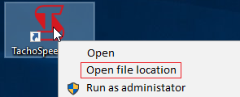
- Find and open „Baza” folder.

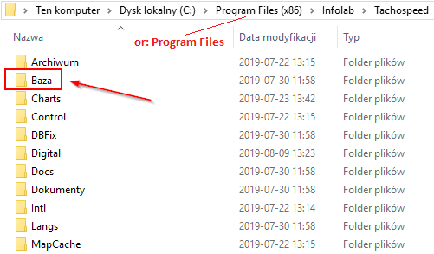

- Copy file: TACHOSPEED.gdb from there on portable device or deskop.

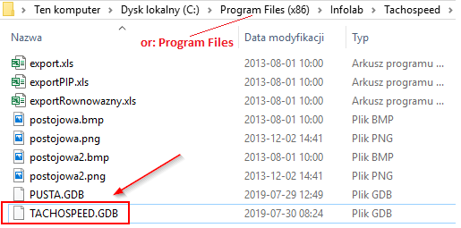

Good job! Your database copy has been done.

In case of problems please contact me.

Greetings.

Best regards.

